**URBAN COLOR MANAGEMENT SYSTEM**

*Empowering Colorful Cities*

**Developed by:**

### RUPA SREE CHILLU

### [214G1A3288@srit.ac.in](mailto:214G1A3288@srit.ac.in)

**Abstract**

**Urban Color Management System** is a specialized Customer Relationship Management (CRM) application designed to manage and coordinate color schemes within urban environments. With the growing emphasis on aesthetic appeal in city planning, managing the diversity of colors across various urban structures—such as buildings, public spaces, and street furniture—has become a complex task. This system provides a comprehensive solution for city planners, architects, and urban developers to maintain and update color schemes effectively.

The system offers features like color palette management, project tracking, and stakeholder communication, all within an intuitive interface. By integrating with existing urban planning tools, the Urban Color Management System enhances collaboration between different teams and ensures consistent color application across projects.

Key benefits include improved efficiency in project management, better communication among stakeholders, and the ability to maintain a cohesive visual identity across urban spaces. This system aims to contribute to the creation of visually appealing cities that reflect a harmonious blend of tradition and modernity.

**INDEX PAGE**

**TOPICS PAGES**

1.Creation salesforce org 01-02

|  |  |
| --- | --- |
| 2.Object | 03-08 |
| 3.Feilds And RelationalShip | 09-11 |
| 4.Page Layouts | 12-13 |
| 5.The Lightning App | 14-16 |
| 6.Profile | 17-20 |
| 7.Setup Roles | 21-22 |
| 8.Users | 23-25 |
| 9.User Adaption | 26-29 |
| 10.Import Data | 30-33 |
| 11.What Are Reports ? | 34-41 |
| 12.Dashboards | 42-45 |

1. **Creating a Developer Account in Salesforce**

### Step 1: Sign Up for a Developer Org

1. **Go to**[developers.salesforce.com/signup](https://developers.salesforce.com/signup).
2. **Click on** "Sign Up."
3. **Fill out the Sign-Up Form** with the following details:

##### First Name & Last Name

* + **Email**
  + **Role**: Developer
  + **Company**: [Your College Name]
  + **Country**: India
  + **Postal Code**: [Your Pin Code]
  + **Username**: Create a username using a combination of your name and company. This does not need to be a valid email; you can format it as [username@organization.com.](mailto:username@organization.com)

1. **Click on "Sign Up"** after filling in all the details.

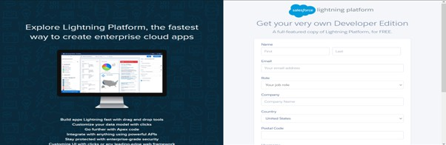

### Step 2: Account Activation

1. **Go to your email inbox** that you used for signing up.
2. **Find the verification email** from Salesforce and click on the "Verify Account" link to activate your account.
   * *Note*: The email might take 5-10 minutes to arrive.

### Step 3: Login to Your Salesforce Account

1. **Go to**[login.salesforce.com](https://login.salesforce.com/).
2. **Enter your username and password** created during the sign-up process.
3. **Login** to access your Salesforce Developer account.
   * You will see the home page after logging in.

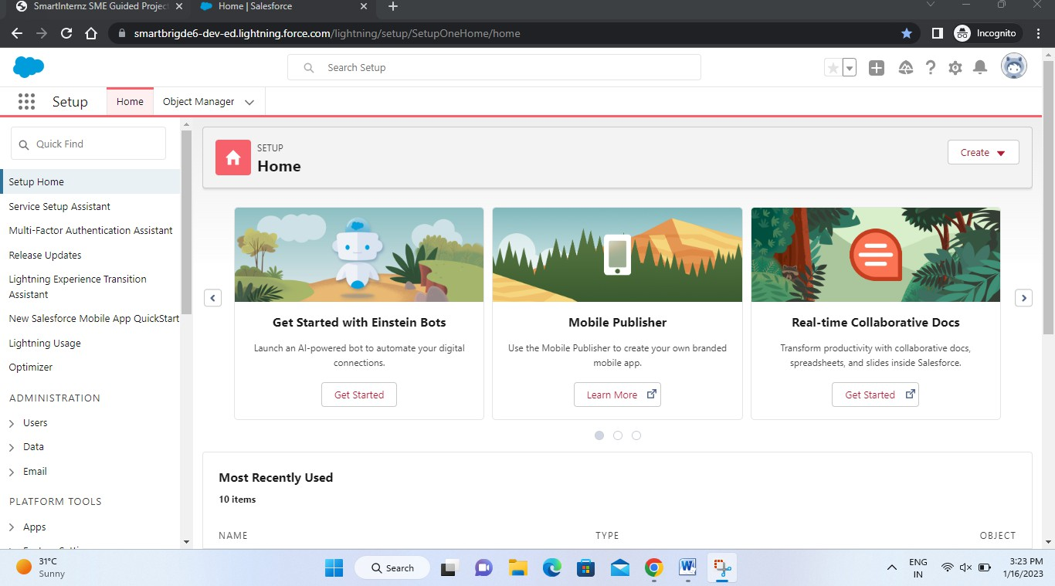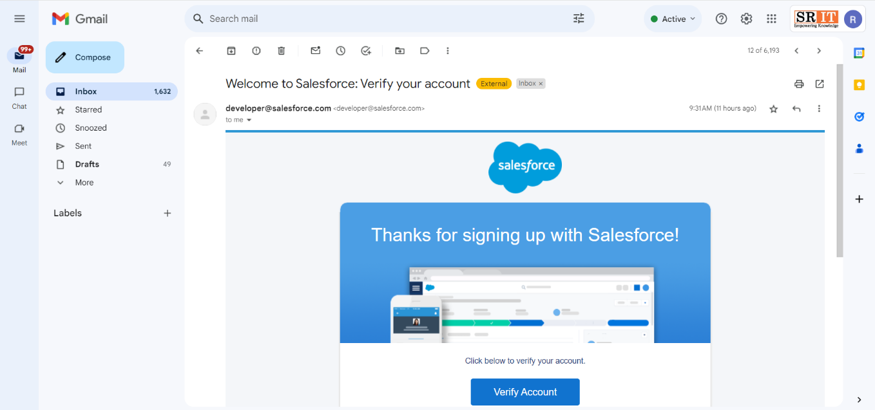

# Salesforce Objects

Salesforce objects are database tables that allow you to store data specific to an organization. Objects in Salesforce are of two types:

1. **Standard Objects**: These are the pre-built objects provided by Salesforce, such as Users, Contracts, Reports, Dashboards, and more. Standard objects form the foundation of Salesforce's data structure and cover common business scenarios.
2. **Custom Objects**: These are user-defined objects created to store data that is unique to your organization’s needs. In the context of the Urban Color Management System, examples of custom objects include **Our Customers**, **Consultants**, **Retailers**, and **Others**.

### Creating Objects for Urban Color Management

In the Urban Color Management System, we need to create three custom objects: **Our Customers**, **Consultants**, **Retailers**, and **Others**. The following steps will guide you through the process of creating these objects in Salesforce.

### Step 1: Access Setup

* + 1. **Click on the gear icon** in the upper-right corner of Salesforce.
    2. **Select "Setup"** from the dropdown menu.

### Step 2: Open Object Manager

1. **Click on the "Object Manager"** tab located next to the Home tab.

### Step 3: Create a Custom Object

1. On the **Object Manager** page, look to the right side of the screen.
2. **Click on the "Create" dropdown** and select **Custom Object**.

### Step 4: Create "Our Customer" Object

1. On the **Custom Object Definition** page, enter the following details:
   * **Label**: Our Customer
   * **Plural Label**: Our Customers
   * **Record Name**: Our Customer
2. **Check the following boxes**:
   * **Allow Reports**
   * **Allow Search**
3. **Click "Save"** to create the object.

### Step 5: Create a Custom Tab for "Our Customer"

1. **Click the "Home" tab** and enter "Tabs" in the Quick Find search bar.
2. **Select "Tabs"** from the search results.
3. Under **Custom Object Tabs**, click **New**.
4. For **Object**, select **Our Customer**.
5. For **Tab Style**, select any icon that represents your object.
6. Leave all other settings as defaults and click **Next**.
7. **Click "Next"** again, then **Save**.

### Creating the Consultants Object

The following steps will guide you through the process of creating the **Consultants** object in Salesforce.

### Step 1: Access Setup

* + 1. **Click on the gear icon** in the upper-right corner of Salesforce.
    2. **Select "Setup"** from the dropdown menu.

### Step 2: Open Object Manager

1. **Click on the "Object Manager"** tab located next to the Home tab.

### Step 3: Create a Custom Object

1. On the **Object Manager** page, look to the right side of the screen.
2. **Click on the "Create" dropdown** and select **Custom Object**.

### Step 4: Create "Consultants" Object

1. On the **Custom Object Definition** page, enter the following details:
   * **Label**: Consultant
   * **Plural Label**: Consultants
   * **Record Name**: Consultant
2. **Check the following boxes**:
   * **Allow Reports**
   * **Allow Search**
3. **Click "Save"** to create the object.

### Step 5: Create a Custom Tab for "Consultants"

1. **Click the "Home" tab** and enter "Tabs" in the Quick Find search bar.
2. **Select "Tabs"** from the search results.
3. Under **Custom Object Tabs**, click **New**.
4. For **Object**, select **Consultants**.
5. For **Tab Style**, select any icon that represents your object.
6. Leave all other settings as defaults and click **Next**.
7. **Click "Next"** again, then **Save**.

### Creating the Retailers Object

The following steps will guide you through the process of creating the **Retailers** object in Salesforce.

### Step 1: Access Setup

* + 1. **Click on the gear icon** in the upper-right corner of Salesforce.
    2. **Select "Setup"** from the dropdown menu.

### Step 2: Open Object Manager

1. **Click on the "Object Manager"** tab located next to the Home tab.

### Step 3: Create a Custom Object

1. On the **Object Manager** page, look to the right side of the screen.
2. **Click on the "Create" dropdown** and select **Custom Object**.

### Step 4: Create "Retailers" Object

1. On the **Custom Object Definition** page, enter the following details:
   * **Label**: Retailer
   * **Plural Label**: Retailers
   * **Record Name**: Retailer
2. **Check the following boxes**:
   * **Allow Reports**
   * **Allow Search**
3. **Click "Save"** to create the object.

### Step 5: Create a Custom Tab for "Retailers"

1. **Click the "Home" tab** and enter "Tabs" in the Quick Find search bar.
2. **Select "Tabs"** from the search results.
3. Under **Custom Object Tabs**, click **New**.
4. For **Object**, select **Retailers**.
5. For **Tab Style**, select any icon that represents your object.
6. Leave all other settings as defaults and click **Next**.
7. **Click "Next"** again, then **Save**.

### Creating the Others Object

The following steps will guide you through the process of creating the **Others** object in Salesforce.

### Step 1: Access Setup

* + 1. **Click on the gear icon** in the upper-right corner of Salesforce.
    2. **Select "Setup"** from the dropdown menu.

### Step 2: Open Object Manager

1. **Click on the "Object Manager"** tab located next to the Home tab.

### Step 3: Create a Custom Object

1. On the **Object Manager** page, look to the right side of the screen.
2. **Click on the "Create" dropdown** and select **Custom Object**.

### Step 4: Create "Others" Object

1. On the **Custom Object Definition** page, enter the following details:
   * **Label**: Other
   * **Plural Label**: Others
   * **Record Name**: Other
2. **Check the following boxes**:
   * **Allow Reports**
   * **Allow Search**
3. **Click "Save"** to create the object.

### Step 5: Create a Custom Tab for "Others"

1. **Click the "Home" tab** and enter "Tabs" in the Quick Find search bar.
2. **Select "Tabs"** from the search results.
3. Under **Custom Object Tabs**, click **New**.
4. For **Object**, select **Others**.
5. For **Tab Style**, select any icon that represents your object.
6. Leave all other settings as defaults and click **Next**.
7. **Click "Next"** again, then **Save**.

# Fields and Relationships

In Salesforce, an object relationship is a two-way association between two objects, allowing users to connect and interact with related data across different objects. This relationship is established by creating custom relationship fields on an object. These relationship fields enable users to view records and seamlessly access related information, providing a comprehensive view of data across the Salesforce environment.

By using relationships, Salesforce ensures that all related data is interconnected, making it easier for users to navigate between related records, improving data consistency, and enhancing the overall user experience.

### Fields in the "Our Customers" Object

The following fields are defined in the "Our Customers" object, each with a specific data type:

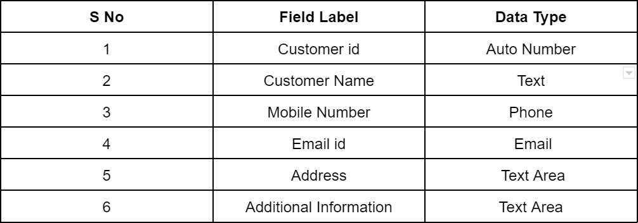

#### Fields in Consultants objects

The following fields are defined in the "Consultants" object, each with a specific data type:

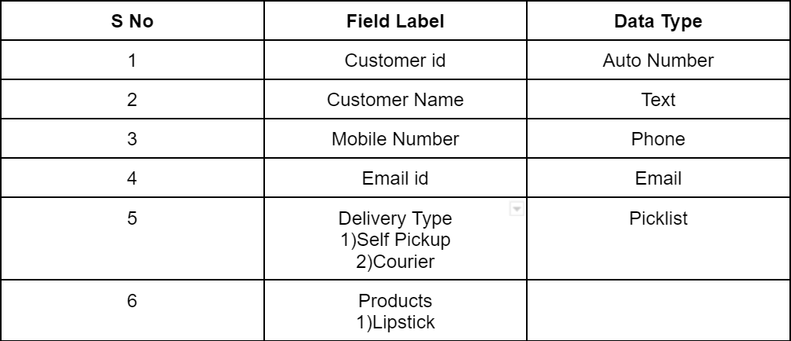

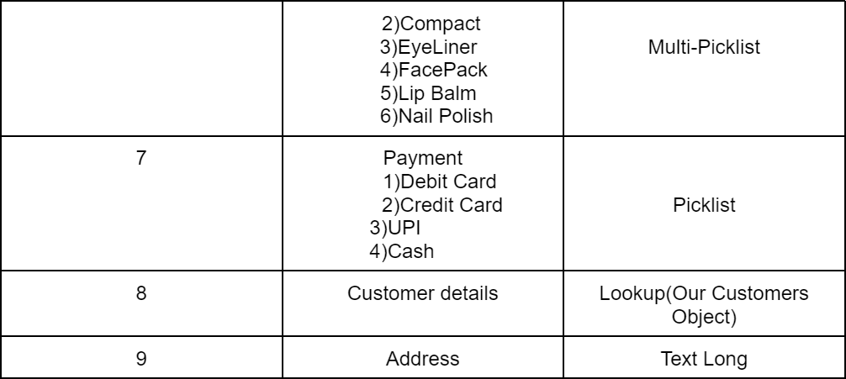

#### Fields in Retailers objects

The following fields are defined in the "Retailers" object, each with a specific data

type:

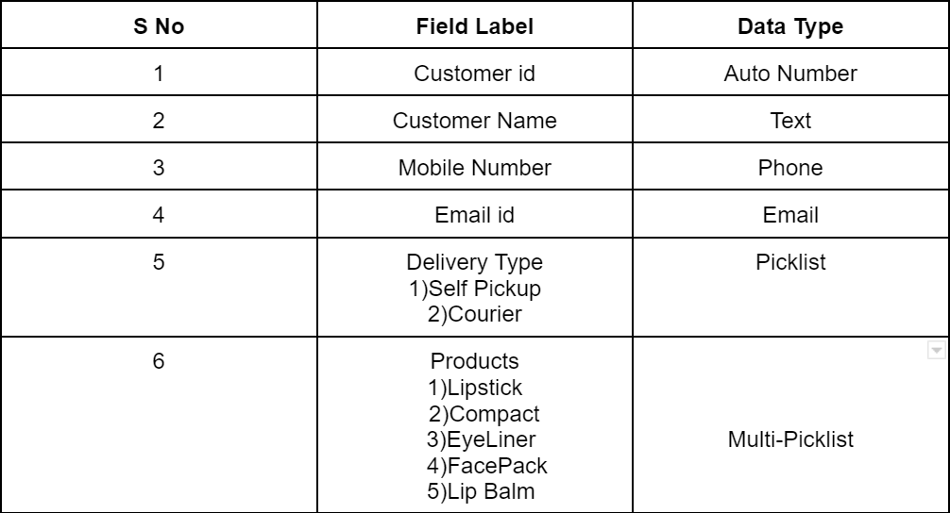

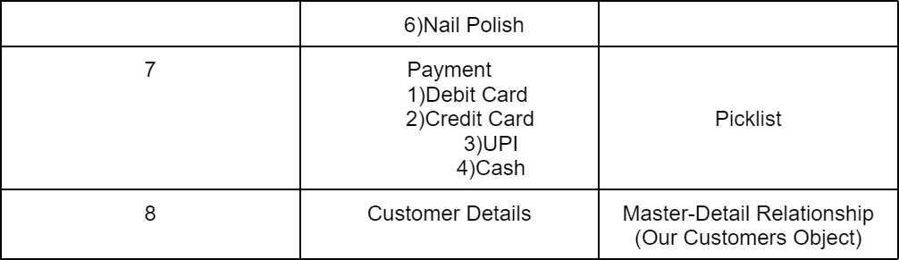

#### Fields in Others objects

The following fields are defined in the "Others" object, each with a specific data

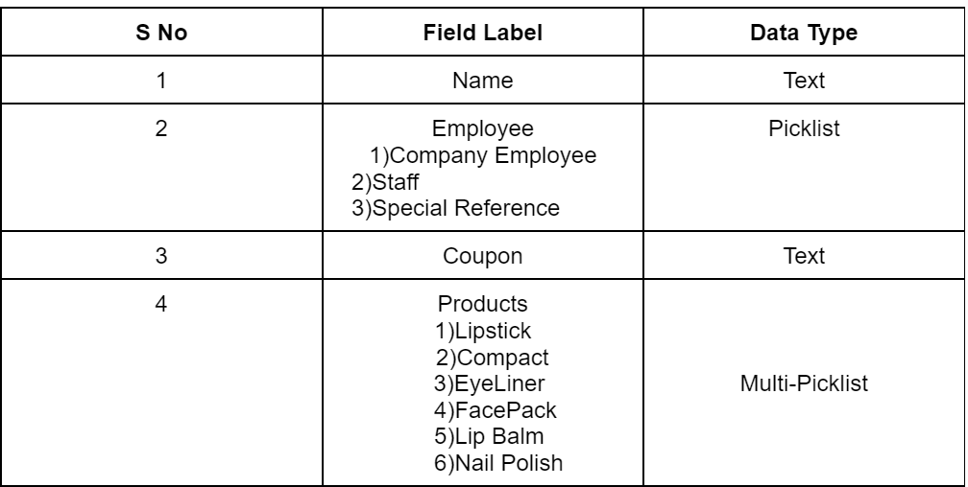type:

# Page Layouts

In Salesforce, page layouts define the organization and arrangement of fields, buttons, related lists, and other components on an object's detail and edit pages. They allow you to control the user interface and tailor it to meet the specific needs of your organization.

##### Page Layout Creation

1. From the Salesforce setup menu, go to **"Object Manager"** and select the **Consultants**

object.

1. Click on **"Page Layouts"** in the left sidebar. This will display a list of available page layouts for the selected object.
2. Select the **Consultant Layout** page layout

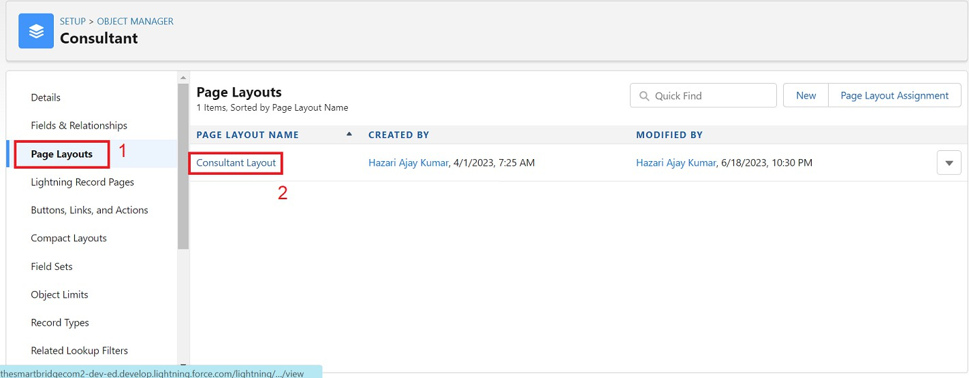

1. Click and drag the **Delivery Type** and **Address** fields below the **Phone** field.

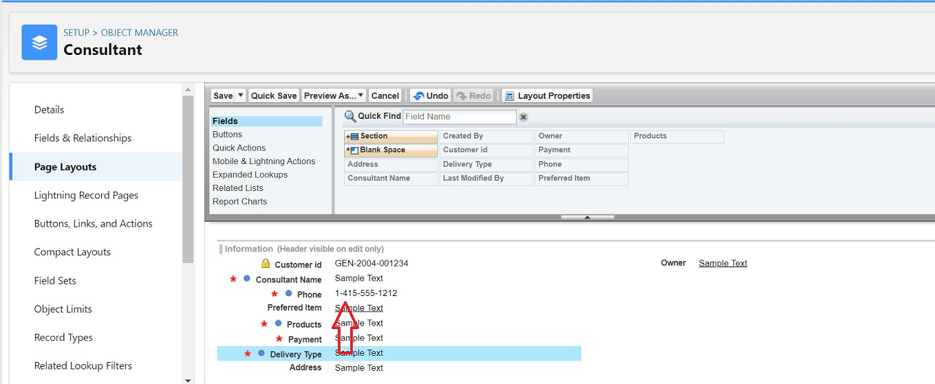

1. Click on **Save**.

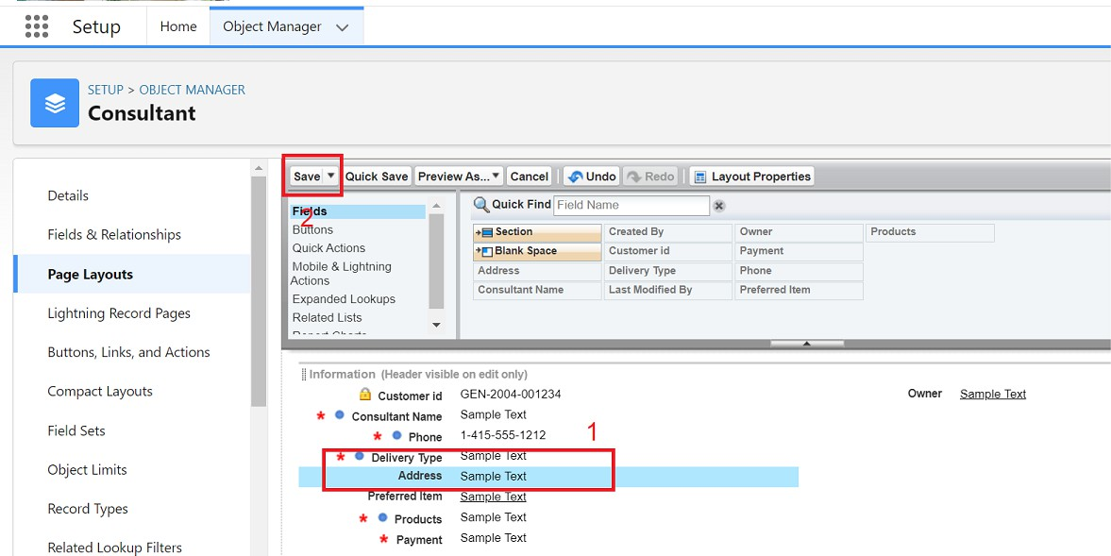

## The Lightning App

An app is a collection of items that work together to serve a particular function. In Lightning Experience, Lightning apps give your users access to sets of objects, tabs, and other items all in one convenient bundle in the navigation bar.

Lightning apps let you brand your apps with a custom Color and logo. You can even include a utility bar and Lightning page tabs in your Lightning app. Members of your org can work more efficiently by easily switching between apps.

### Create a Lightning App

To create a Lightning app page:

* + 1. Go to the **Setup** page.
    2. In the **Quick Find** search bar, type **“App Manager”** and select **“App Manager.”**
    3. Click on **New Lightning App**.
       - Fill the app name as **Urban Color** in **App Details and Branding**.
       - Click **Next**.
       - On the **App Options** page, keep the settings as default.
       - Click **Next**.
       - On the **Utility Items** page, keep the settings as default.
       - Click **Next**.

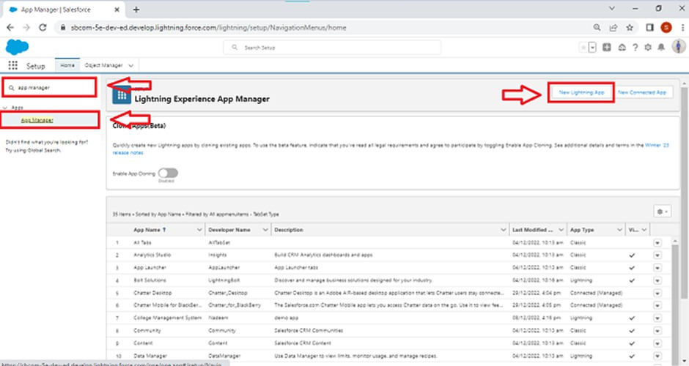

##### To Add Navigation Items:

1. Select the items **(Our Customers, Consultants, Retailers, Others, Reports, Dashboards)**

from the search bar and move them using the arrow button.

1. Click **Next**.

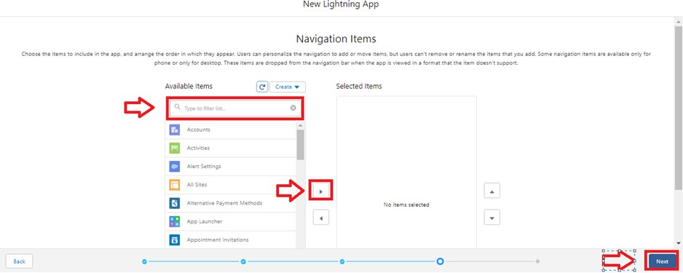

##### To Add User Profiles:

1. Search for **profiles (System Administrator)** in the search bar.
2. Click on the arrow button to add the profile.
3. Click **Save & Finish**.

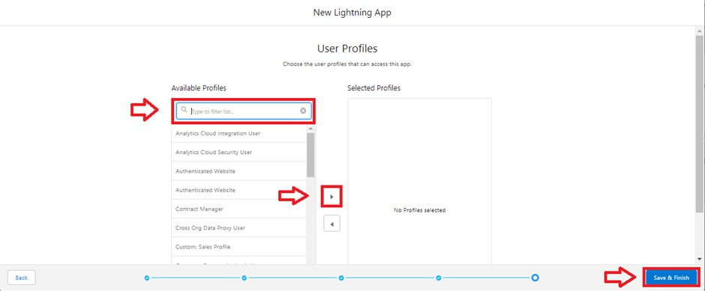

## Profile

A profile is a group/collection of settings and permissions that define what a user can do in salesforce. A profile controls “Object permissions, Field permissions, User permissions, Tab settings, App settings, Apex class access, Visualforce page access, Page layouts, Record Types, Login hours & Login IP ranges.

### Creating a Profile

##### Creating a Store Supervisor Profile and Setting Object Permissions:

* + 1. From **Setup**, enter **Profiles** in the **Quick Find** box, and select **Profiles**.
    2. From the list of profiles, find **Standard User**.
    3. Click **Clone**.
    4. For **Profile Name**, enter **Store Supervisor**.
    5. Click **Save**.

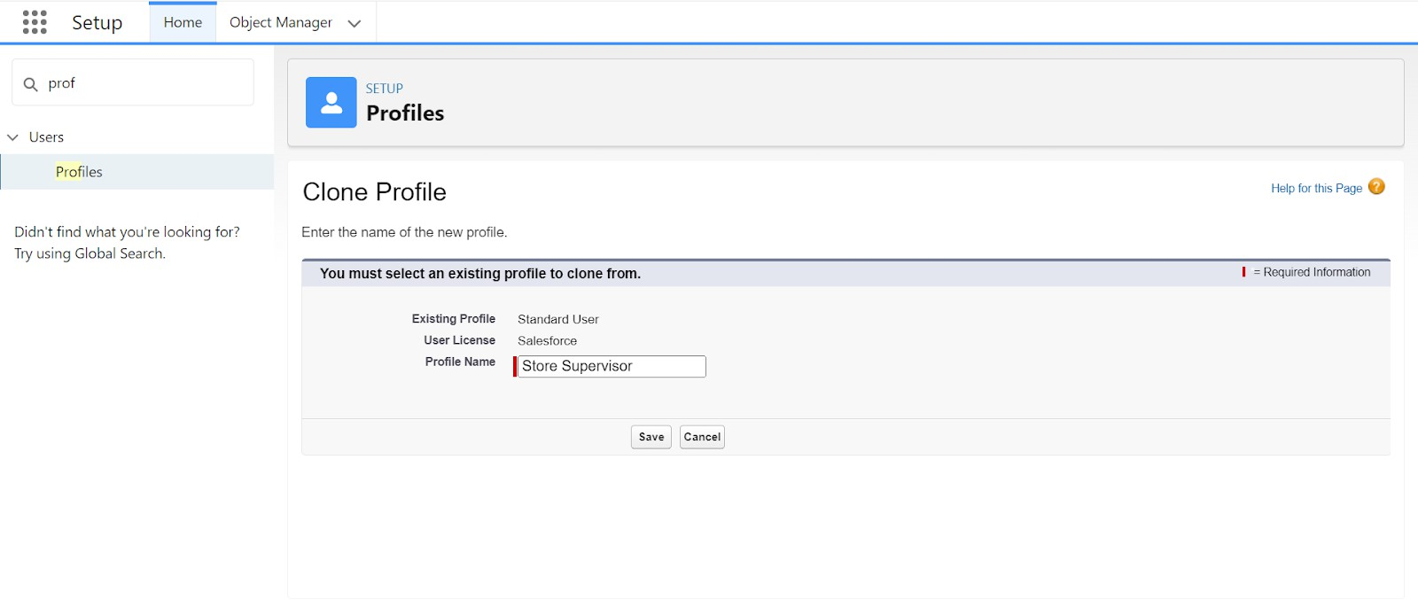

* + 1. While still on the **Store Supervisor** profile page, click **Edit**.
    2. Scroll down to **Custom Object Permissions** and give access for **Create, Read, Edit, Delete, View All, and Modify All** for the **Our Customers, Consultants, Retailers, Others** objects.

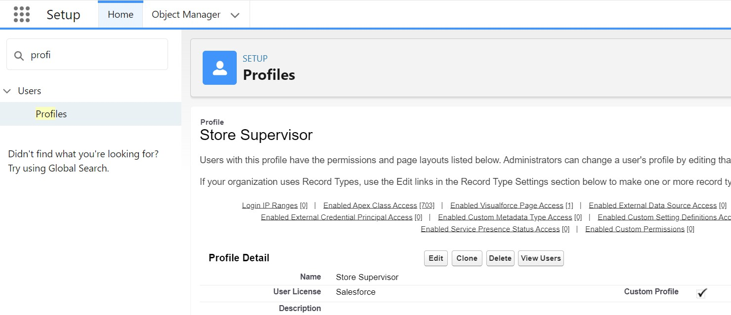

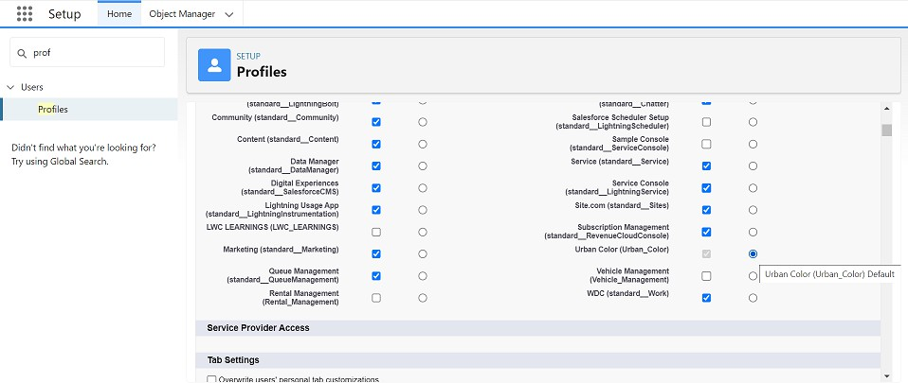

* + 1. Scroll down to **Custom App Settings** and give access to **Urban Color**.
    2. Click on **Save**.

##### To Create a New Profile:

1. Go to **Setup**.
2. Type **Profiles** in the **Quick Find** box.
3. Click on **Profiles**.
4. Clone the desired profile (**Standard User** is preferable).
5. Enter the **Profile Name**.
6. Click **Save**.
7. While still on the profile page, click **Edit**.



1. Scroll down to the **Custom Object Permissions** and give all access to the **Consultants, Others, Our Customers, Retailers** objects.
2. Click on **Save**.

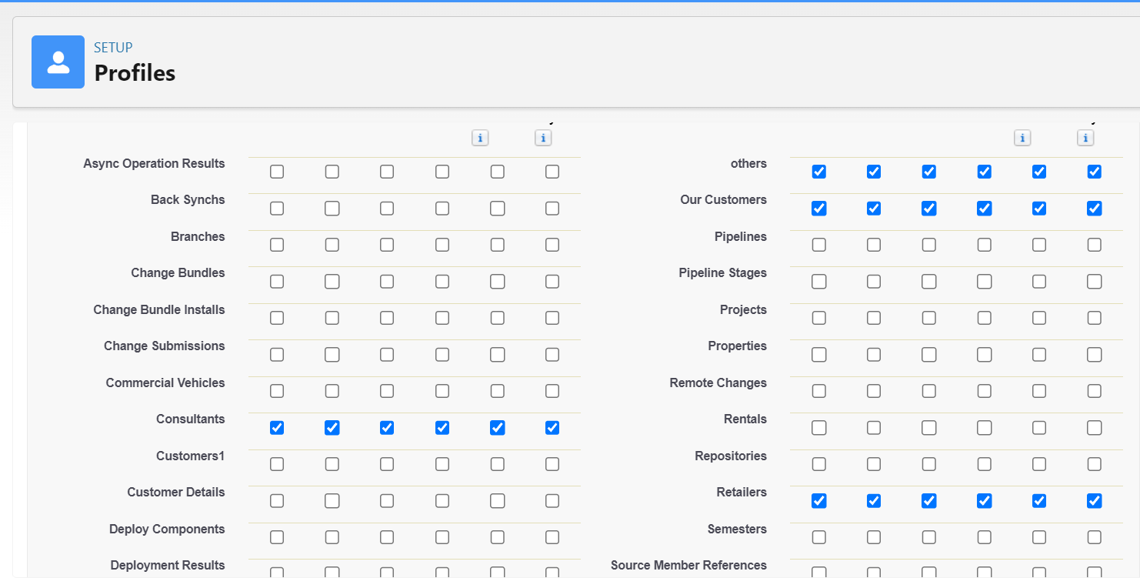

##### Similarly, Create an Operator Profile:

1. Clone the **Salesforce Platform** user profile.
2. Give access only for **Billing Operator**.

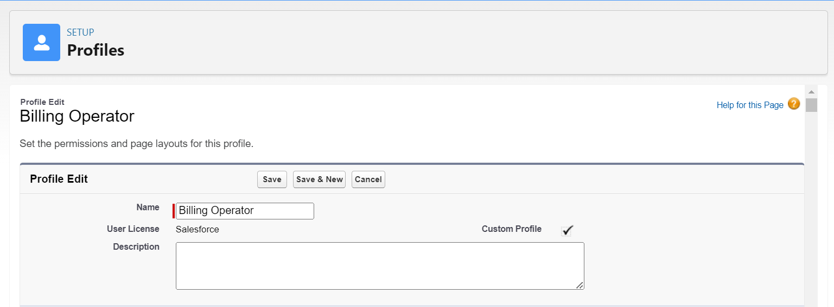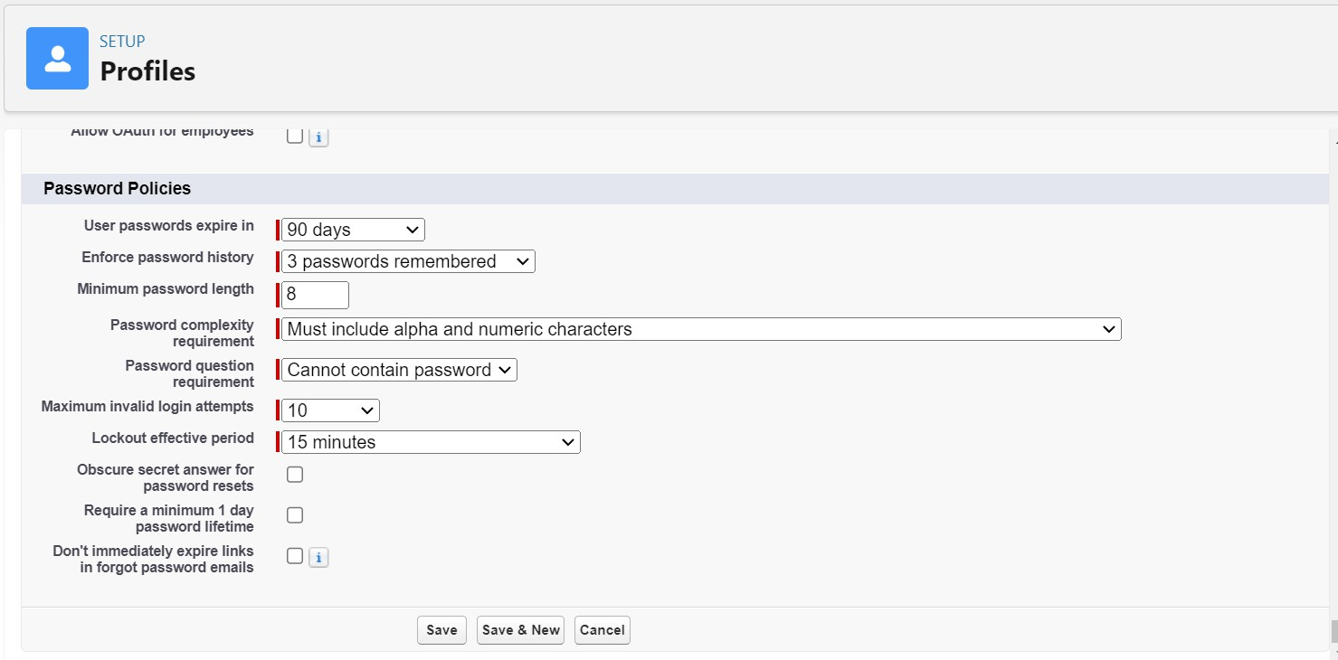

1. Click on **Save**.

## Setup Roles

Roles are record-level access controls that define what data a user can see in Salesforce.

##### Setup Roles

1. Click on the **Gear Icon**.
2. Click **Setup**.
3. In the **Quick Find** box, enter **Roles**.
4. Click **Roles**.
5. Click on **Set Up Roles**.
6. Click **Expand All**.
7. Under the **CEO**, click on **Add Role**.
8. Fill in the **Label** as **Store Head**, and the **Role Name** as **Store_Head**.
9. Enter a **Role Name** that will be displayed on reports.
10. Click on **Save**.

**Similarly, create one role under Store Head as Billing Operator.**

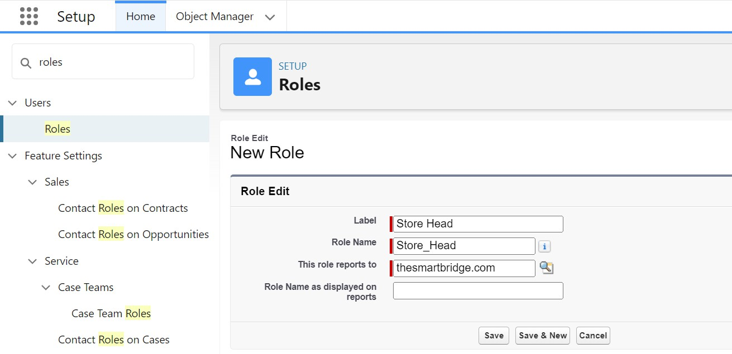

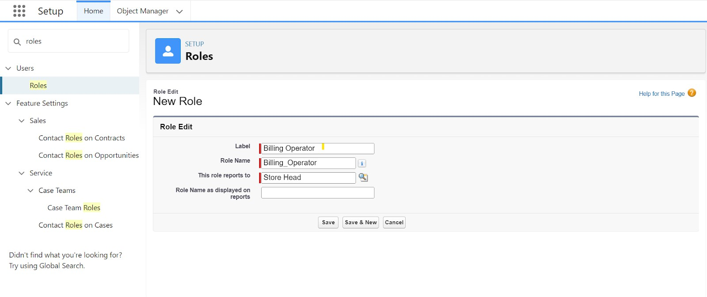

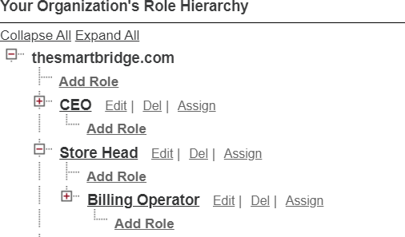

## Users

A user is anyone who logs in to Salesforce. Users are employees at your company, such as sales reps, managers, and IT specialists, who need access to the company's records. Every user in Salesforce has a user account.

##### Creating a User:

1. From **Setup**, in the **Quick Find** box, enter **Users**, and then select **Users**.
2. Click **New User**.
3. Enter the user’s name as **Amar K** and your email address, and create a unique username in the form of an email address. By default, the username is the same as the email address.
4. Select a **Role** as **Store Head**.
5. Select a **User License** as **Salesforce**.
6. Select a **Profile** as **Store Supervisor**.
7. Check **Generate new password and notify the user immediately** to have the user’s login name and a temporary password emailed to your email.
8. Fill in the fields (First Name, Last Name, Alias, Email ID, Username, Nickname, Role, User License, Profile).
9. Click **Save**.

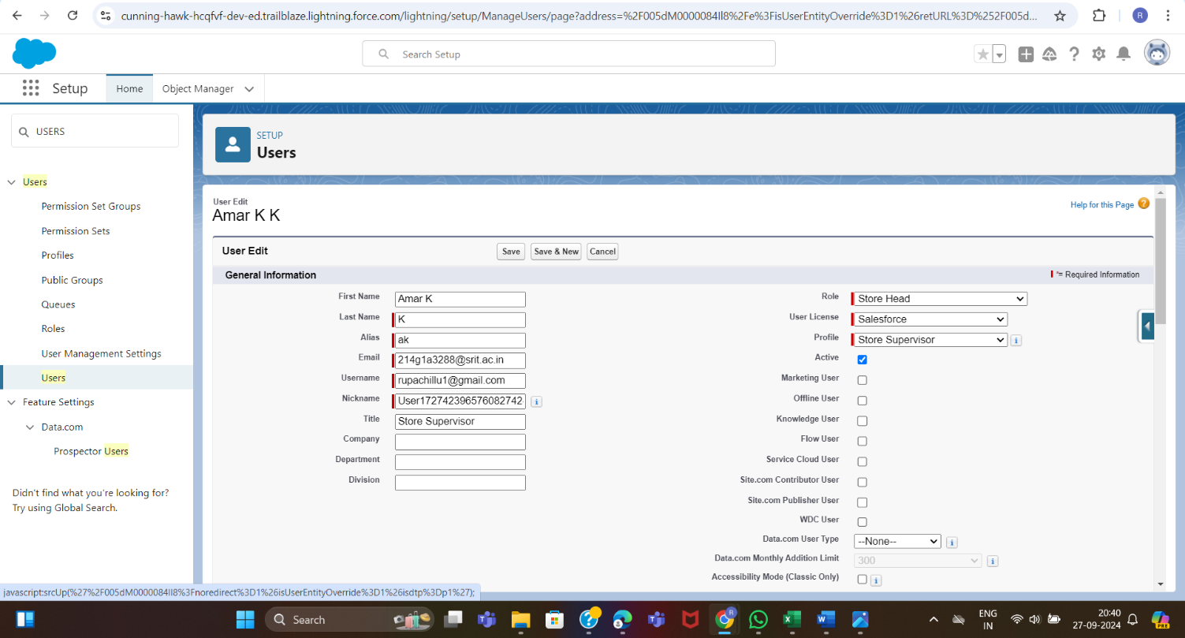

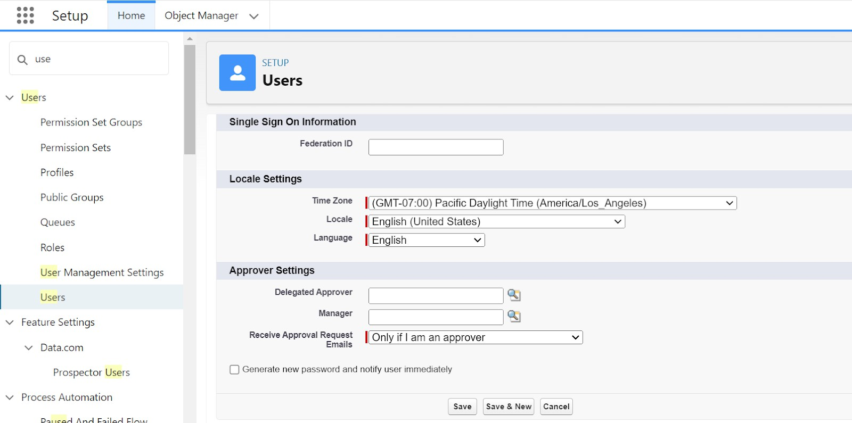

##### Second User Creation:

1. From **Setup**, in the **Quick Find** box, enter **Users**, and then select **Users**.
2. Click **New User**.
3. Enter the user’s name as **John Teddy** and your email address, and create a unique username in the form of an email address. By default, the username is the same as the email address.
4. Select a **Role** as **Billing Operator**.
5. Select a **User License** as **Salesforce Platform**.
6. Select a **Profile** as **Billing Operator**.
7. Check **Generate new password and notify the user immediately** to have the user’s login name and a temporary password emailed to your email.
8. Fill in the fields (First Name, Last Name, Alias, Email ID, Username, Nickname, Role, User License, Profile).
9. Click **Save**.

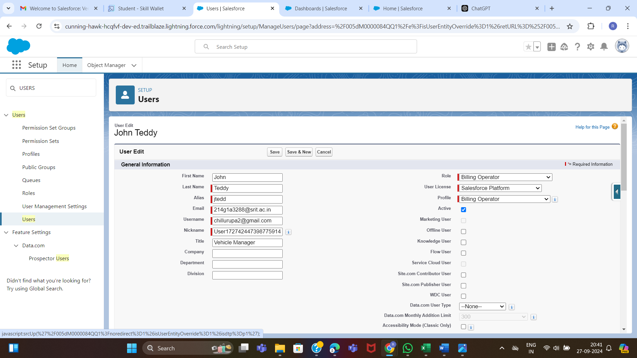

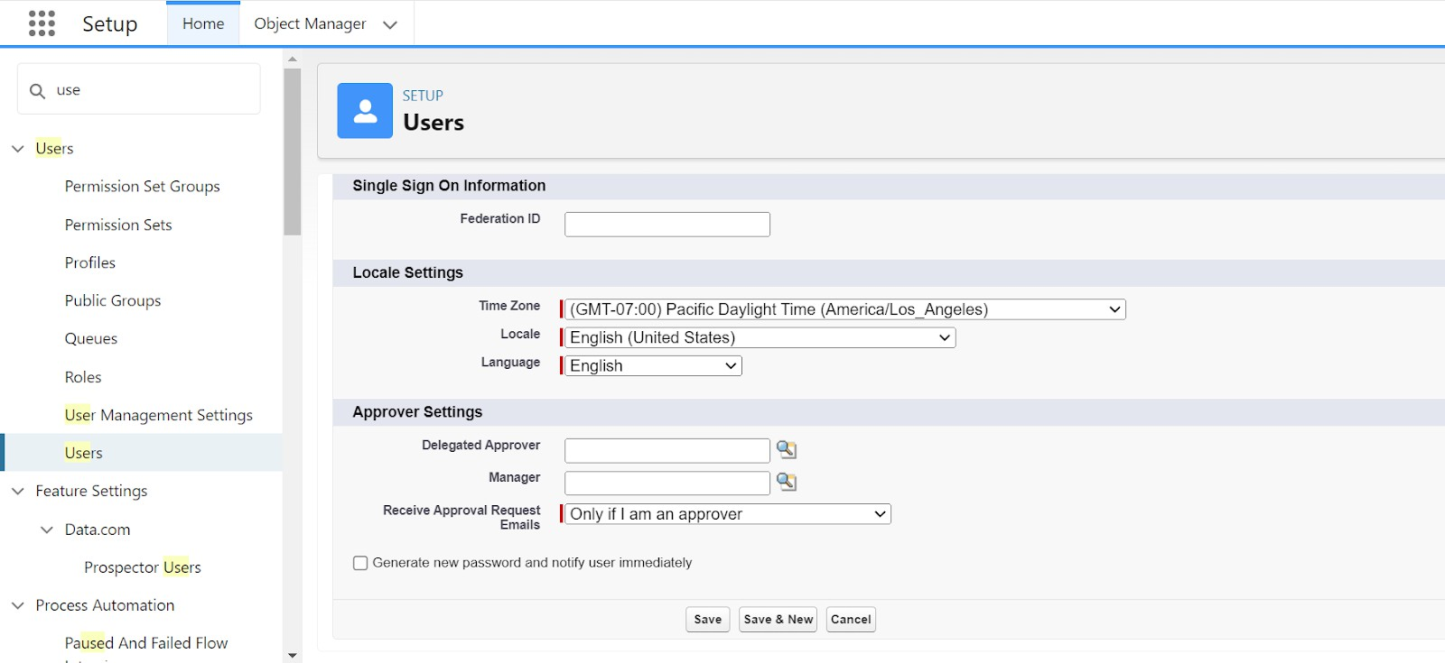

1. User Adoption

We need to understand user adoption and navigation. How to interact with database and their records.

To ensure effective **user adoption** and navigation, it's important to educate users on how to interact with the Salesforce database and manage records. The following steps outline key areas to focus on:

##### Create Our Customer Record

1. Click on the **App Launcher** on the left side of the screen.
2. Search for **Urban Color** and click on it.
3. Click on the **Our Customer** tab.
4. Click the **New** button.
5. Fill in all the **Our Customer** record details.
6. Click on the **Save** button.

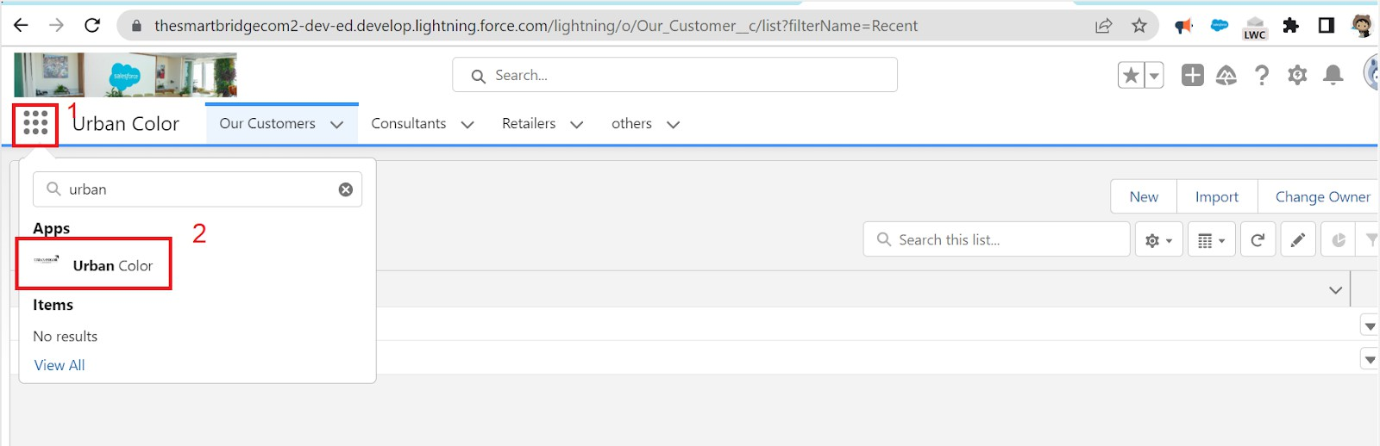

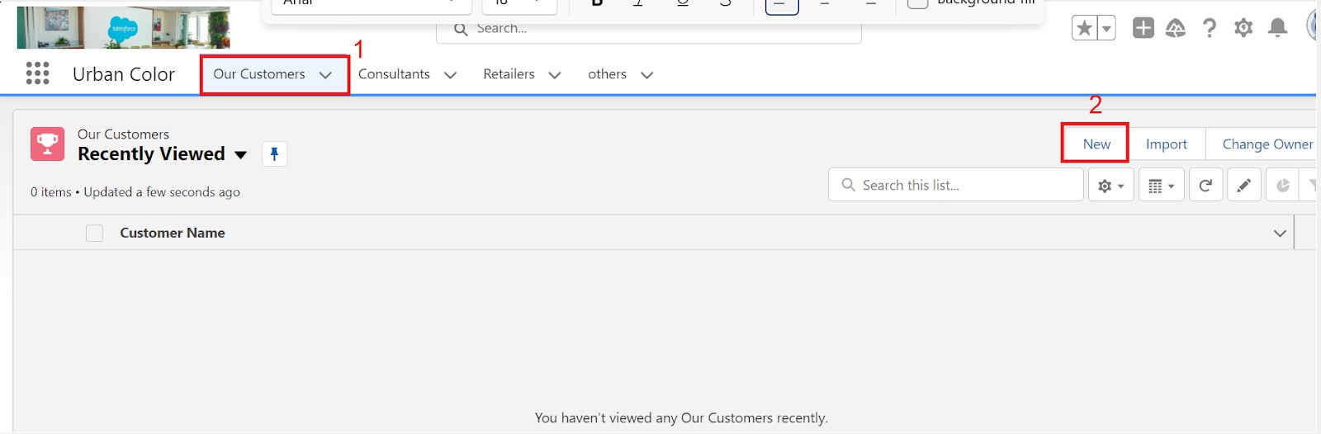

### View Record (Our Customer)

1. Click on the **App Launcher** on the left side of the screen.
2. Search for **Urban Color** and click on it.
3. Click on the **Our Customer** tab.
4. Click on any **record name** to view the details of the **Our Customer**.

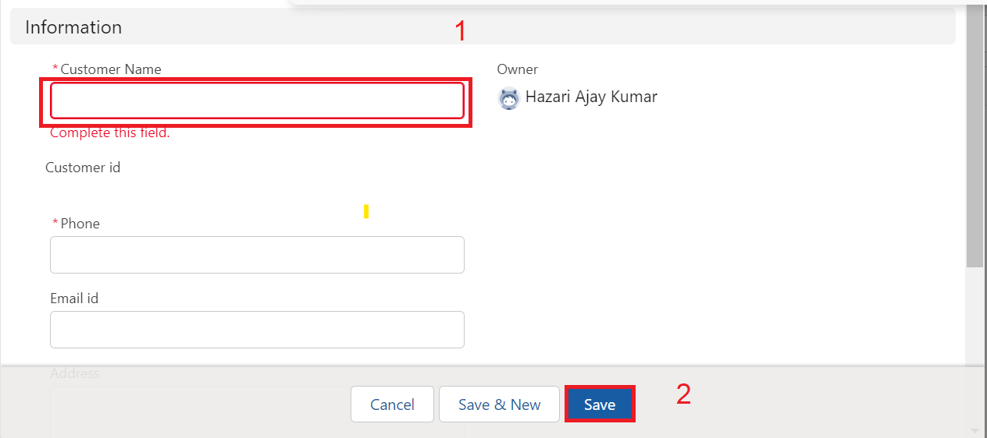

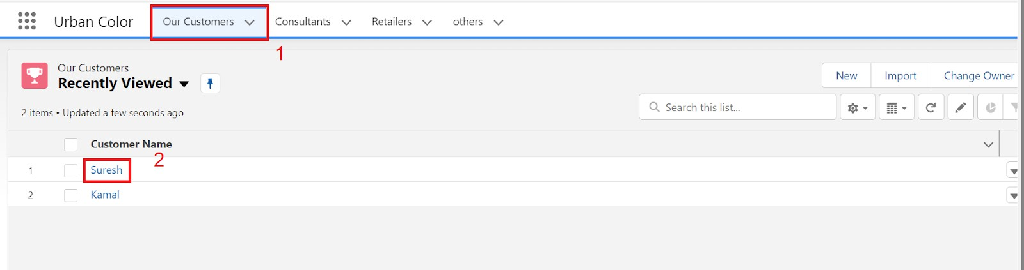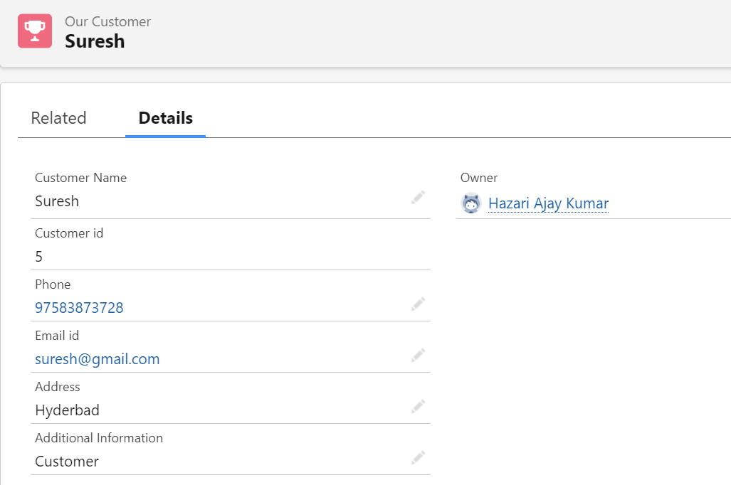

### Delete Record (Our Customer)

1. Click on the **App Launcher** on the left side of the screen.
2. Search for **Urban Color** and click on it.
3. Click on the **Our Customer** tab.
4. Click on the **Arrow** on the right-hand side of the particular record.
5. Click **Delete**, and then confirm by clicking **Delete** again.

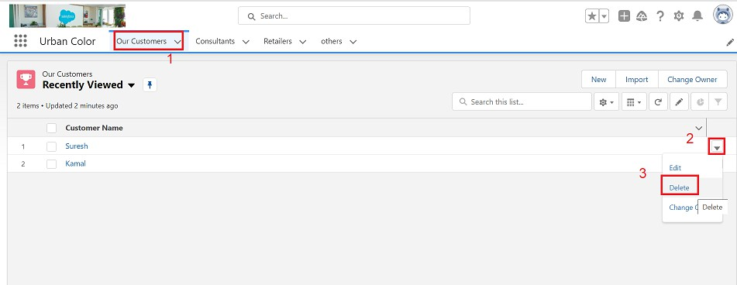

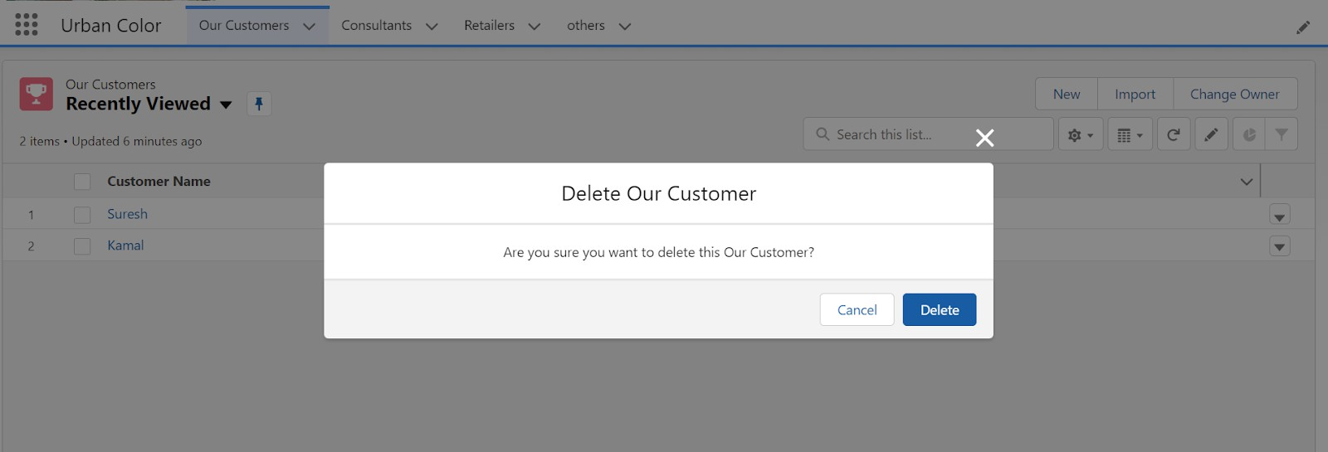

# Import Data

**Data Import Wizard**—This tool, accessible through the **Setup** menu, allows you to import data into common standard objects such as **Contacts, Leads, Accounts**, as well as data into custom objects.

##### To Import Data

1. From **Setup**, click the **Home** tab.
2. In the **Quick Find** box, enter **Data Import** and select **Data Import Wizard**.

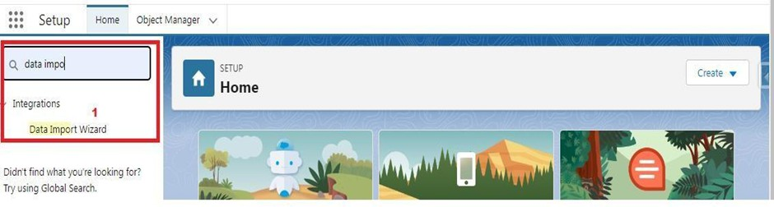

1. Click **Launch Wizard!**

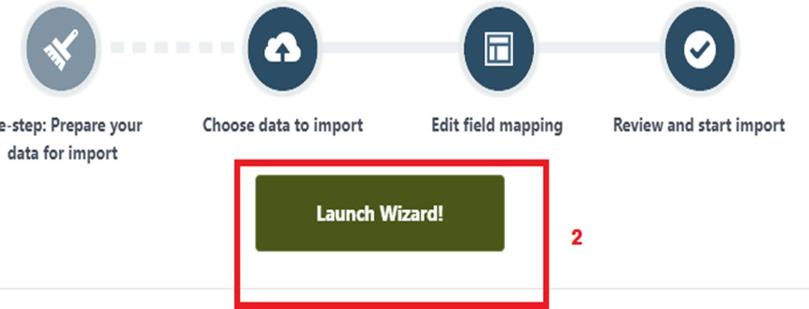

1. Click the **Custom Objects** tab and select the **Consultant** object

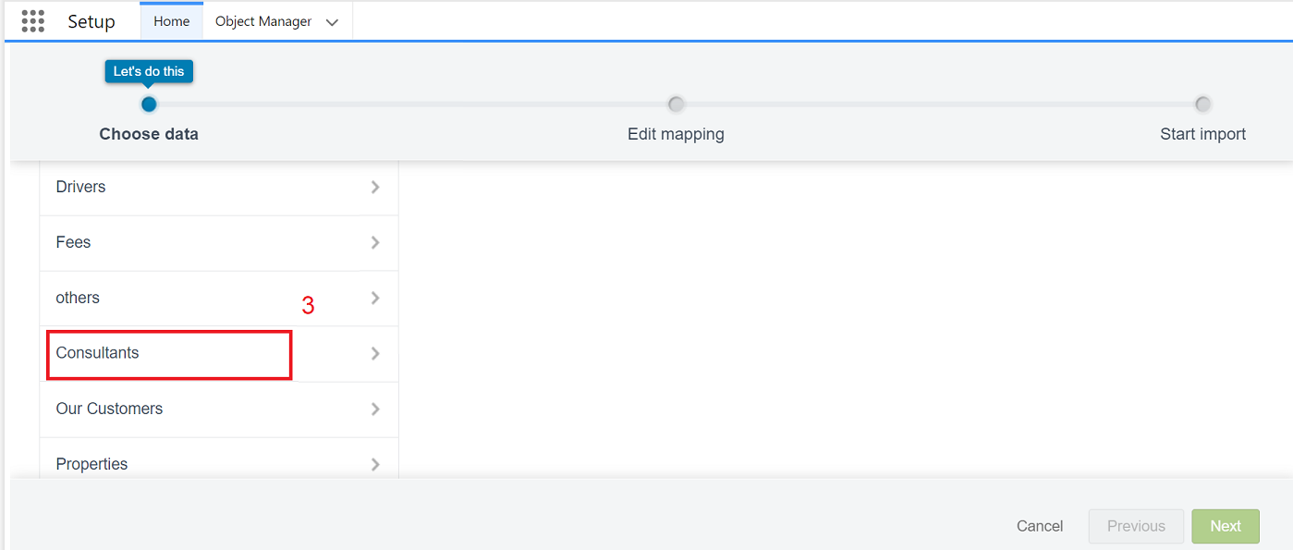

1. Select **Add New Records**.

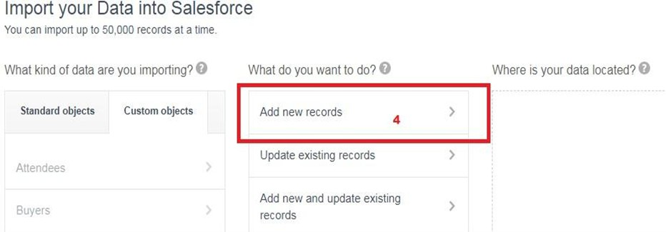

1. Click **CSV** and choose the file **Consultant_CSV** which was created earlier. Click **Next**.

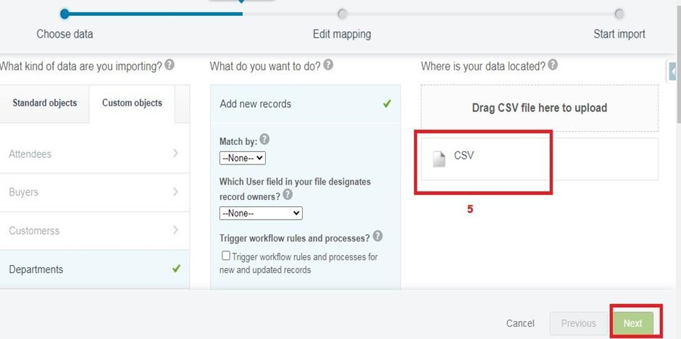

1. Since the field names in the CSV file (CSV Header) are the same as the field names in your object (Mapped Salesforce Object), the fields are automatically mapped. Click **Next**.

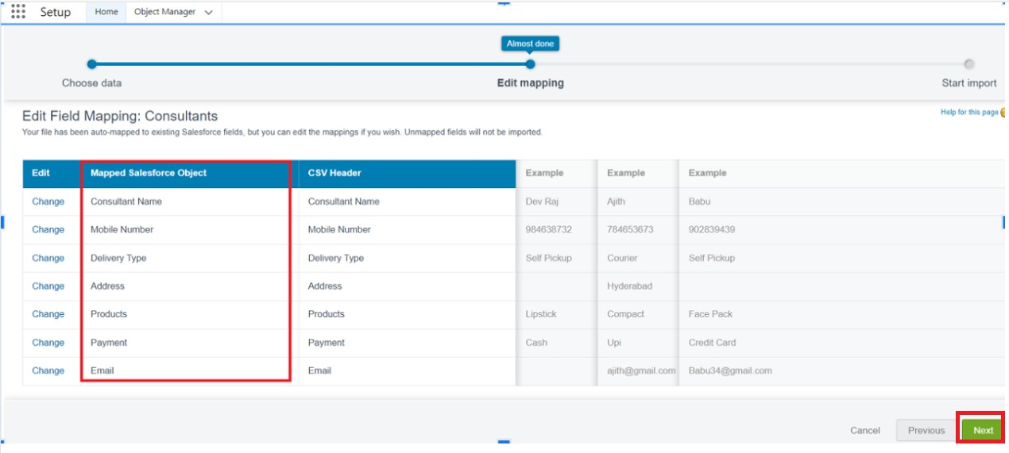

1. The next screen gives you a summary of your data import. Click **Start Import**.

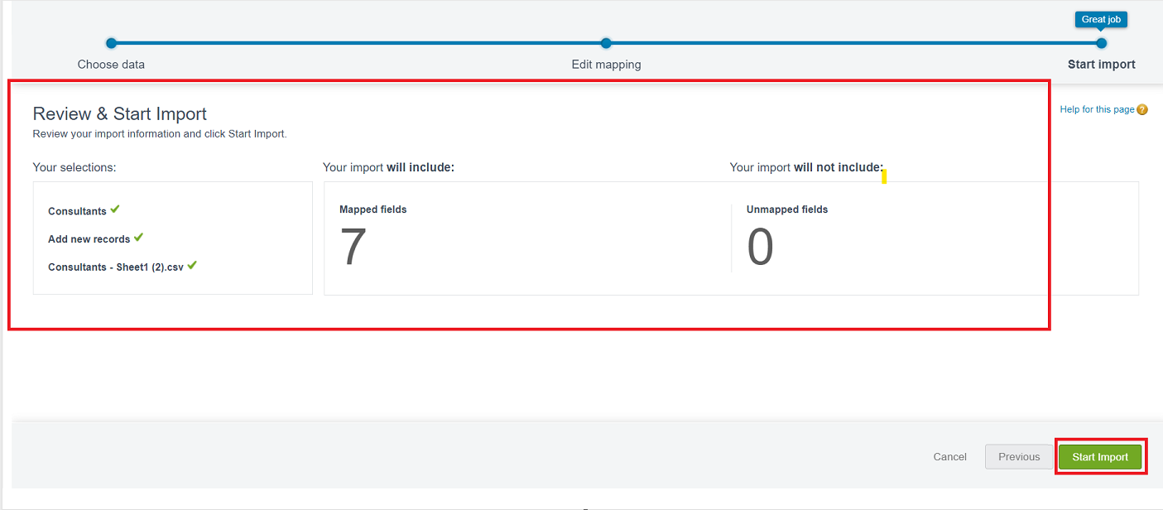

1. Click **OK** on the popup.

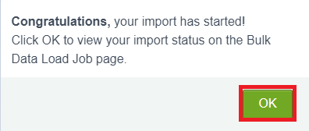

1. Scroll down the page and verify that your data has been imported under **Batches**.



1. Make sure you have **0 records** under the **Records Failed** column.

**Note:** Perform **Field Mapping** carefully.

Here is the formatted text for your document:

## What are Reports?

##### Reports

Reports in Salesforce are lists of records that meet specific criteria, providing answers to particular questions. These records are displayed in a table format that can be filtered or grouped based on any field.

##### There are 4 types of report formats in Salesforce:

1. **Tabular Reports:**
   * The most basic report format, displaying rows of records in a table with a grand total.
   * Easy to set up but cannot be used to create groups of data or charts and cannot be used in Dashboards.
   * Primarily used to generate simple lists or lists with a grand total.

##### Summary Reports:

* + The most commonly used report format, allowing the grouping of rows of data, viewing subtotals, and creating charts.

##### Matrix Reports:

* + The most complex report format, summarizing information in a grid format.
  + Allows records to be grouped by both columns and rows.
  + Can be used to generate dashboards and add charts.

##### Joined Reports:

* + Allows the creation of different views of data from multiple report types.
  + Data in joined reports is organized in blocks, each acting as a subreport with its own fields, columns, sorting, and filtering.
  + Used to group and show data from multiple report types in different views.

##### Report Types:

A **Report Type** determines which set of records will be available in a report. Each report is based on a particular report type, selected first when creating a report. Every report type has a primary object and one or more related objects, all of which must be linked together directly or indirectly.

* A report type cannot include more than 4 objects.
* Once a report is created, its report type cannot be changed.

##### There are 2 types of report types:

1. **Standard Report Types:**
   * Automatically included with standard objects and custom objects where "Allow Reports" is checked.
   * Cannot be customized and automatically include standard and custom fields for each object within the report type.
   * Created when an object or a relationship is created.
   * **Note:** Standard report types always have inner joins.

##### Custom Report Types:

* + Created by an administrator or user with "Manage Custom Report Types" permission when standard report types cannot specify which records will be available in reports.
  + Allows specification of objects that will be available in a particular report.
  + The primary object must have a relationship with other objects present in the report type, either directly or indirectly.

##### There are 3 types of access levels for folders:

1. **Viewer:**
   * Users can see the data in a report but cannot make any changes except cloning it into a new report.

##### Editor:

* + Users can view and modify the reports and move them to/from any other folders they have access to as Editor or Manager.

##### Manager:

* + Users can do everything Viewers and Editors can do, plus control other users' access levels to the folder.
  + Managers can also delete the report.

### Create Report

* + 1. Click **App Launcher**.
    2. Select **Urban Color App**.
    3. Click the **Reports** tab.

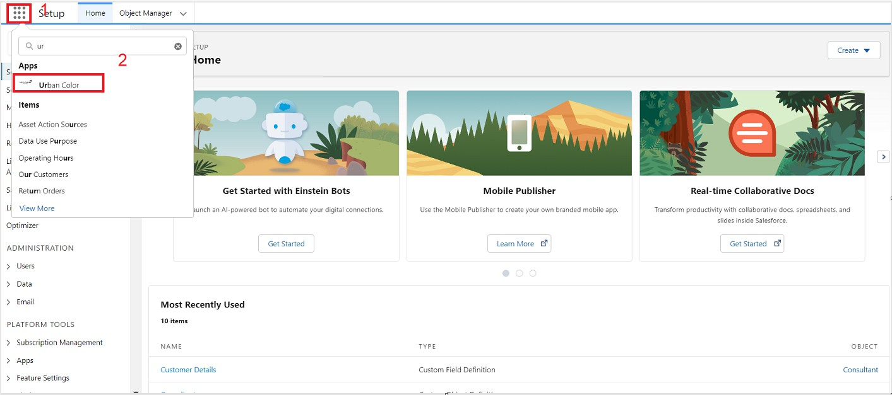

* + 1. Click **New Report**.

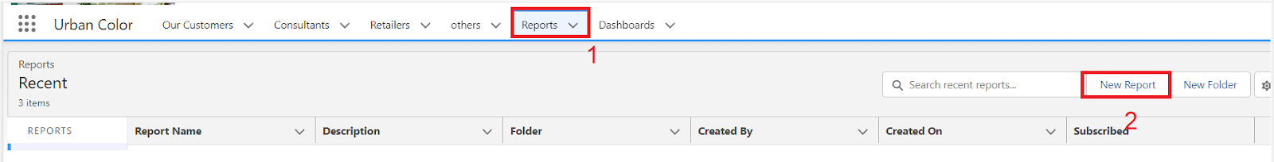

* + 1. Select the report type as **Consultants** and click **Start Report**.
    2. Customize your report by selecting the following columns: **Consultant Name, Delivery Type, Products, Payment**.

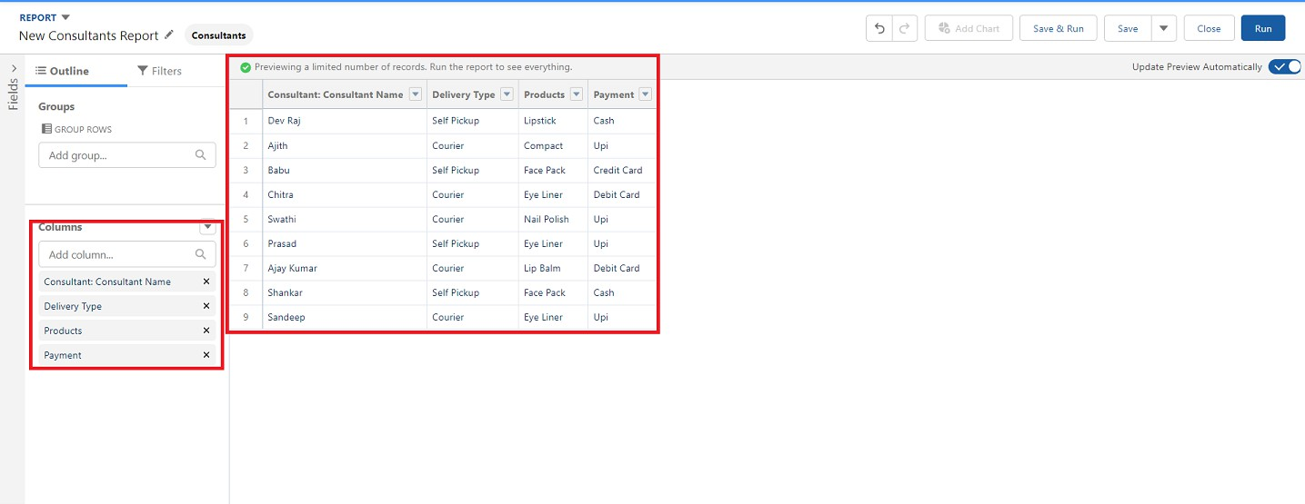

* + 1. Click the drop-down option on the **Payment** column and select **Bucket This Column**.

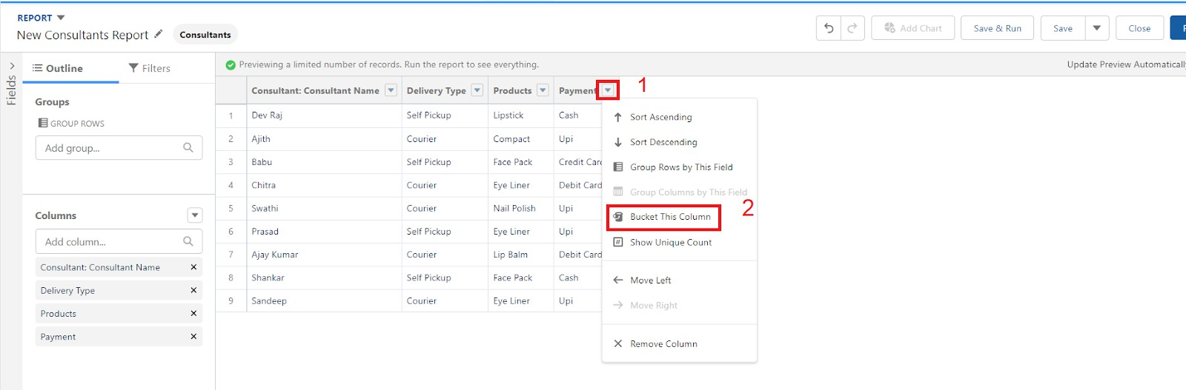

* + 1. Name the bucket **Payment Type**.

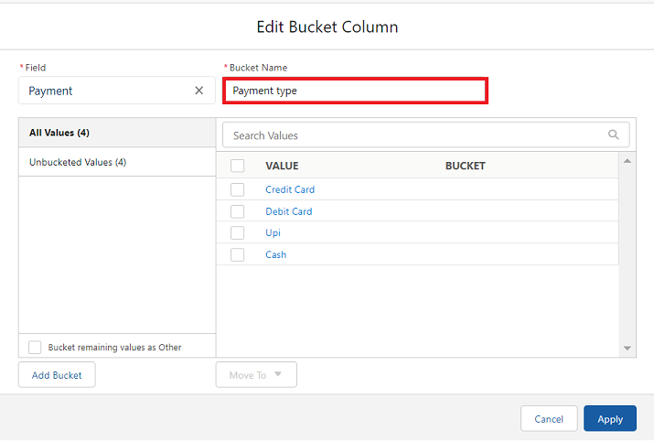

* + 1. Click **Add Bucket** and name it **NetBanking**.
    2. Click **Add Bucket** and name it **Cash**.

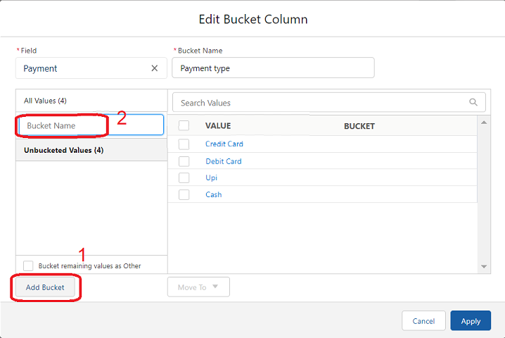

* + 1. Click on **All Values**, select **Credit Card, Debit Card, UPI**, and move them to **NetBanking**.

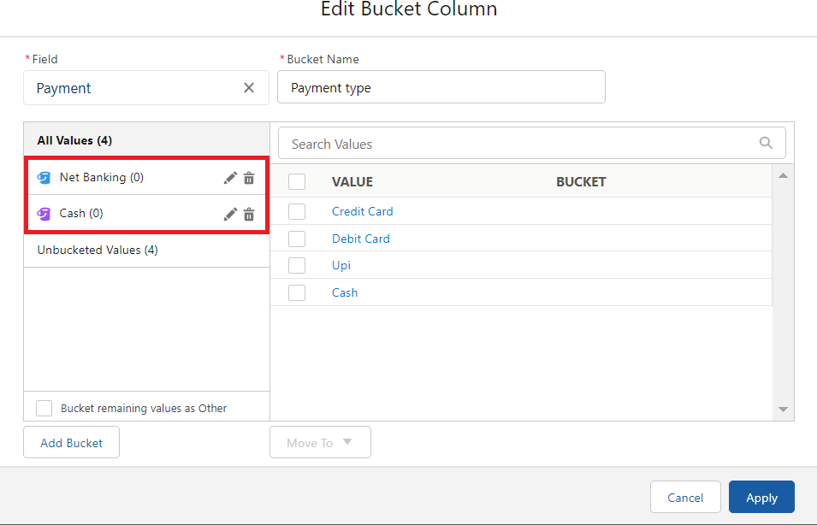

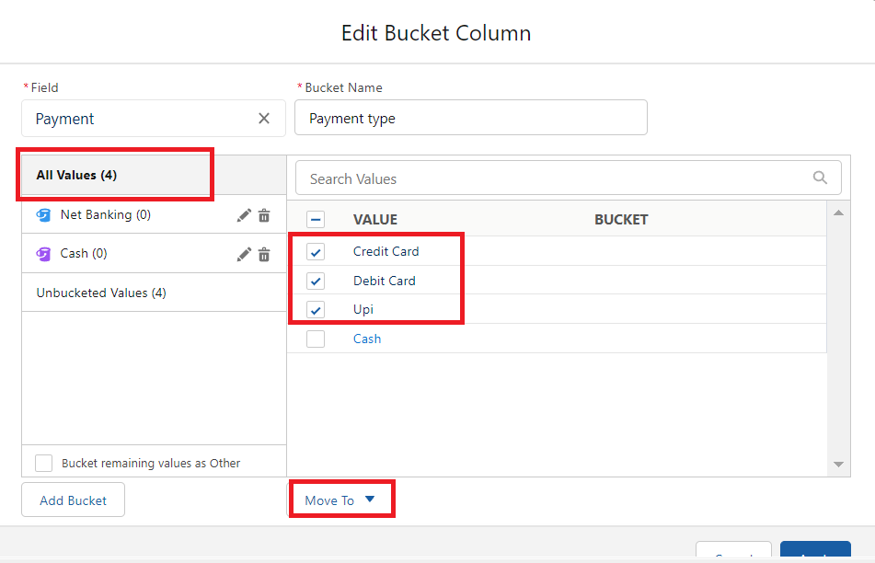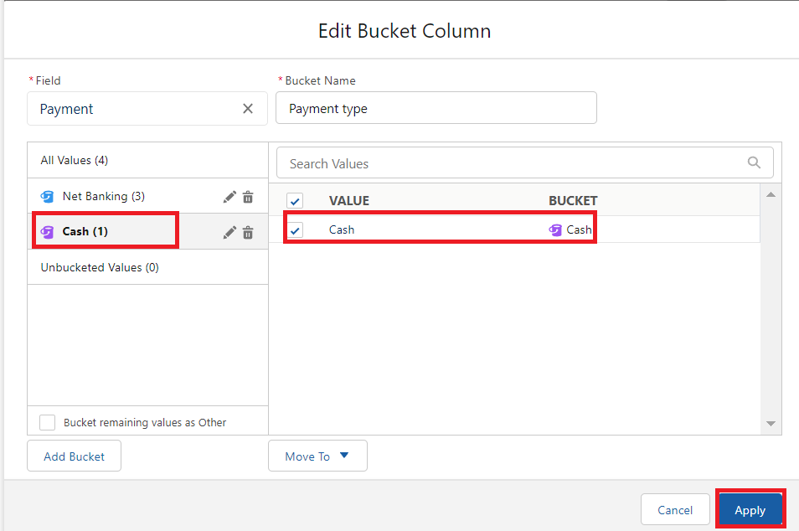

* + 1. Click on **All Values** again, select **Cash**, and move it to **Cash**.
    2. Click **Apply**.
    3. 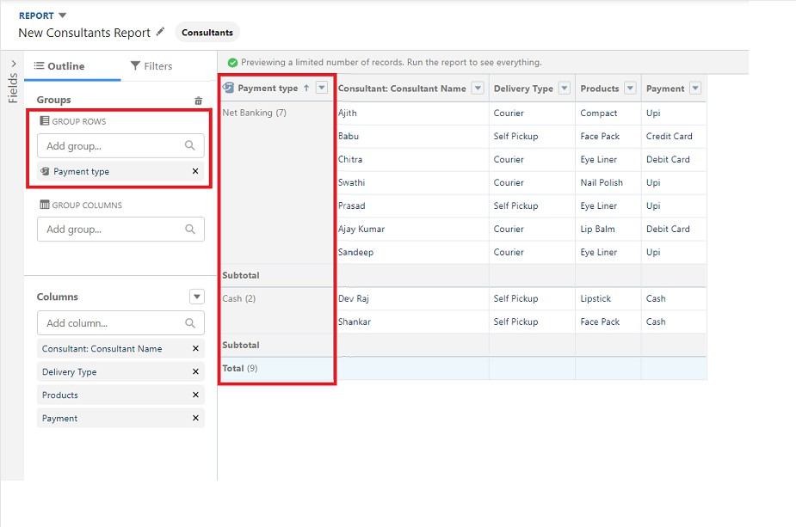In **Group Rows**, add the **Payment Type Bucket** field.
    4. Click **Refresh**.
    5. Click **Save and Run**.
    6. Give the report a name, e.g., **Consultant Report**.



* + 1. Click **Save**.

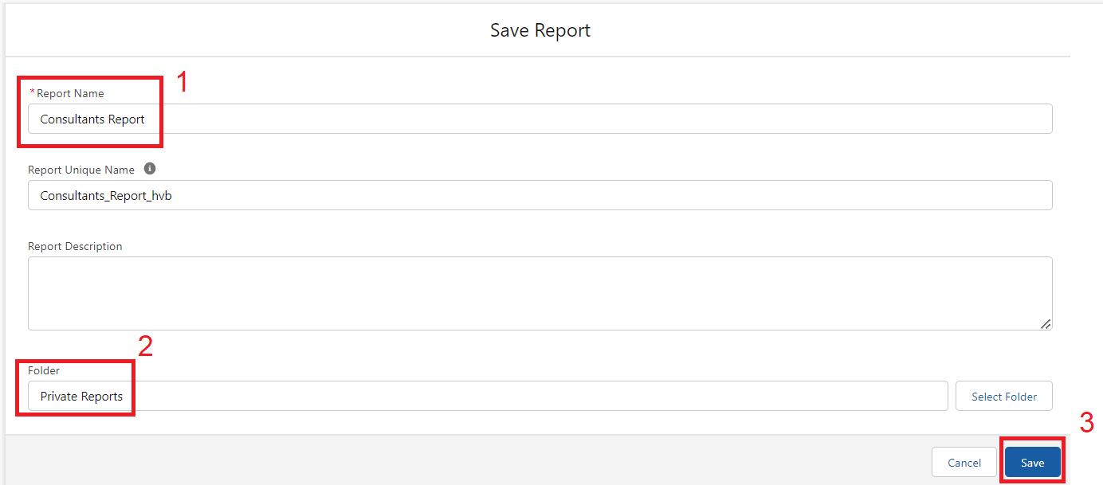

### View Report

* + 1. Click on the **App Launcher** on the left side of the screen.
    2. Search for **Urban Color App** and click on it.



* + 1. Click the **Reports** tab.
    2. Click on the **Urban Color Report** to view the records.

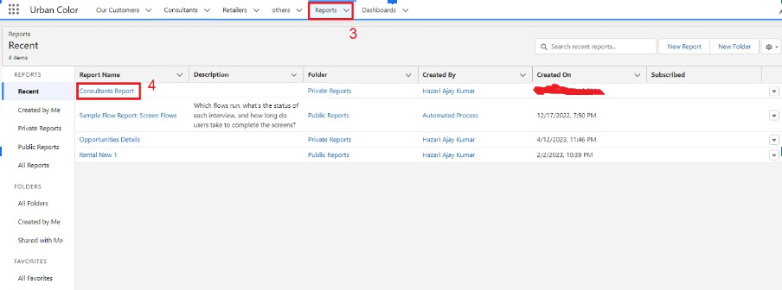

## Dashboards

Dashboards let you curate data from reports using charts, tables, and metrics. If your colleagues need more information, then they're able to view your dashboard's data supplying reports. Dashboard filters make it easy for users to apply different data perspectives to a single dashboard.

#### Create Dashboard

Here’s a step-by-step guide to creating a dashboard in the Urban Color application:

1. **Open the Urban Color Application**: Launch the application and navigate to the Dashboards tab.

##### Create a New Dashboard:

* + Click on the "New Dashboard" button.

##### Name Your Dashboard:

* + Enter "Consultant Dashboard" in the name field.
  + Click "Create."

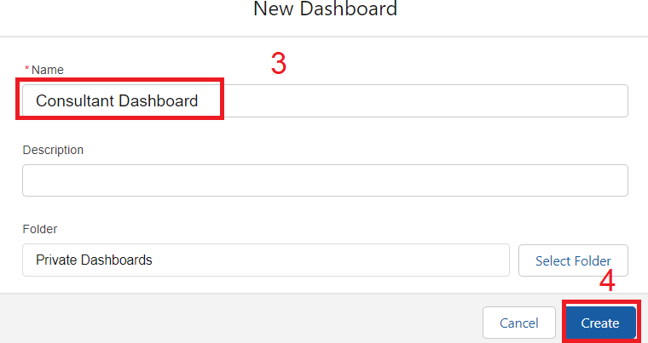

##### Add Components to the Dashboard:

* + Click on "+ Component" to add a new component.
  + Select the "Consultants Report" you created earlier.

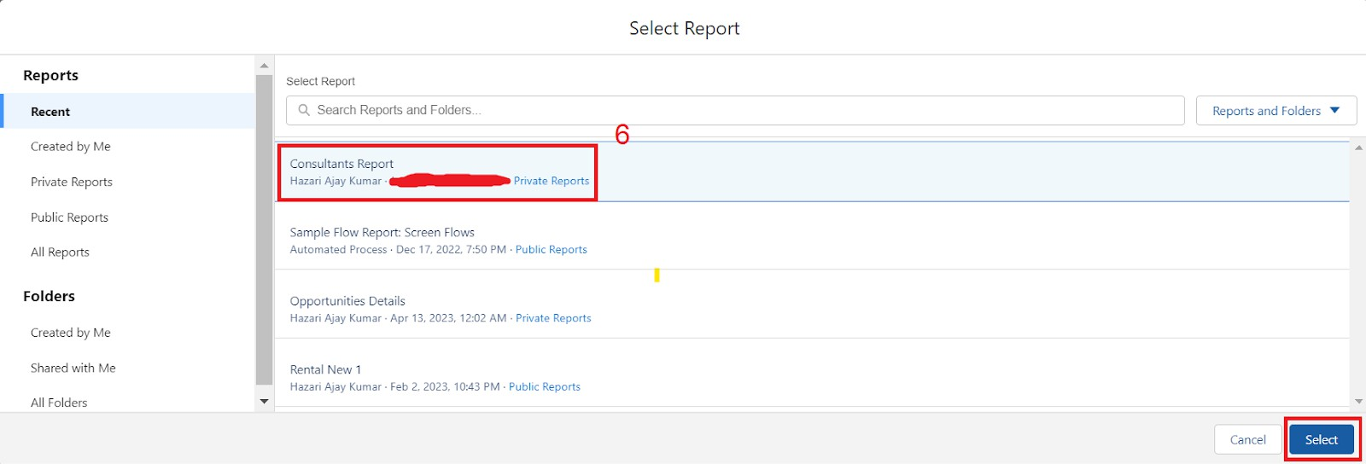

##### Choose Data Visualization:

* + Pick a visualization type (e.g., chart, table) that best suits your data and needs.
  + Click "Add."

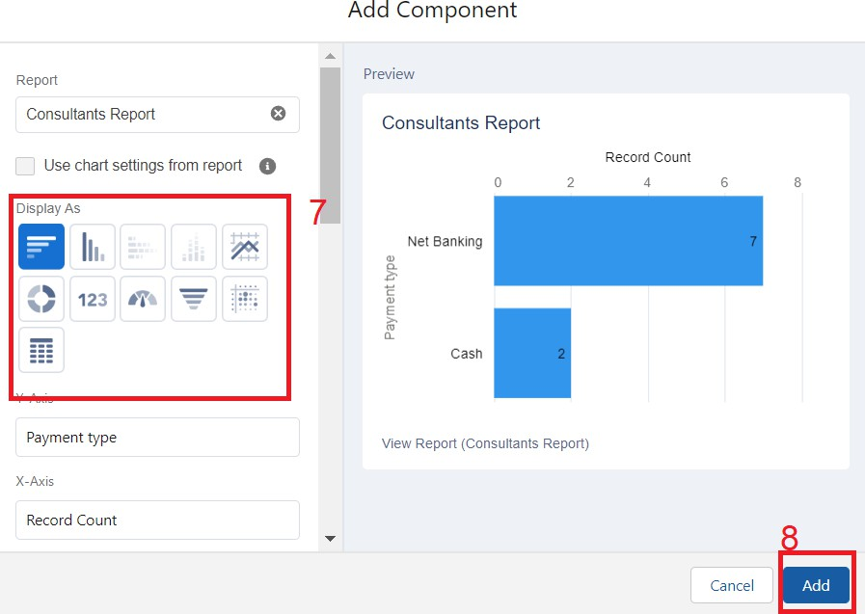

##### Save Your Dashboard:

* + After configuring the components and visualizations, click "Save" to finalize your dashboard.

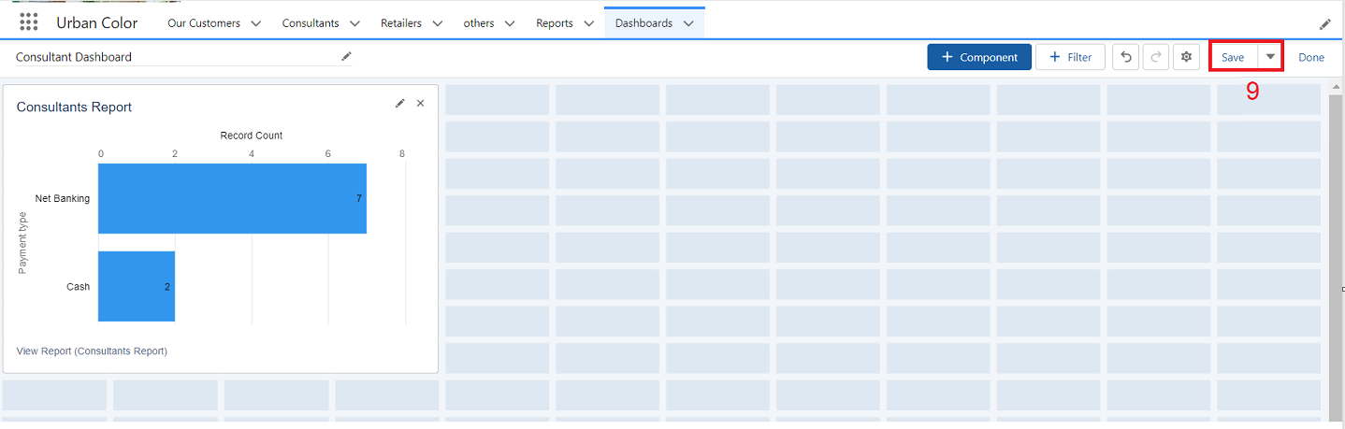

## View Dashboard

To view the dashboard, follow these steps:

##### Open the App Launcher:

Click on the App Launcher icon on the left side of the screen.

##### Search for the Dashboard:

Type "Candidate Internal Result Card" into the search bar.

Click on the "Candidate Internal Result Card" option that appears.



##### Navigate to the Dashboard Tab:

Once in the Candidate Internal Result Card view, click on the "Dashboard" tab.

##### View the Graph:

Click on the "Candidate Internal Result Card" to see the graph view of the records.

